KISINGA COMMUNITY CLEAN WATER PROJECT
P.O.BOX 142
KASESE-UGANDA

REFERENCE: TRANSITIONAL SUSTAINABILITY PLAN.
FOR KISINGA COMMUNITY CLEAN WATER PROJECT.

It’s genuinely good to think of a reliable trend towards a self supportive and reliable project as many community development projects do.
The kind of planning is nevitable as it serves as mitigation against several un expected challenges and risks that might interfere with the project’s long life processes, expectations and signals for the next generations.

Many sponsored projects in developing countries like Uganda are normally implemented with ambitions of permanency of which the sustainability plan is always their foundations.

During this transitional process, the project implementers have revisited critically the following proposed activities which were suggested as turning points through out the implementation of the transition plan of action.

A) Give- a duck revolving scheme
B) Supported savings and credit scheme
C) Newly established piloting water zones without prior knowledge concerning sand filter project.

DETAILED DESCRIPTION OF EACH ABOVE

- Give A Duck
Ducks are resistant to poultry diseases, can be grazed on free range, cant move to distant places to meet birds of prey animals and encroachers , their duckling are easy to take care of .

Ducks are good for white meat and have local market. Therefore, if shared a among project beneficiaries they can supplement both house hold income and nutritional level and also their droppings can be recycled into Kitchen garden manure.

DIRECT BENEFITS TO THE PROJECT
When a central committee gives five ducklings to the beneficiary he/she will be expected to pass on to the next beneficiary five duckling and in another development she/he gives back five duckling to the central executive committee who may redistribute or sell the same and get funds for financial demanding services of the project like fuel, stationary, communication e.t.c

Give –a duck project is a self fabricating enterprise that is to say if the central committee gives out one hundred ducklings will expect one hundred ducklings back phase I and will expect the second give back from the beneficiaries , therefore the central committee shall receive back from any beneficiary who shall receive until the last project beneficiary.

GIVE – A DUCK PROJECT IMPLIMENTATION PROCEDURE.

- Training of beneficiaries at sub-zonal level by the veterinary officer and community based extension workers.
- Identification of qualified beneficiaries
- Distribution of ducklings
- Follow ups and monitoring
- Evaluation and reporting

FUNDING

Local contribution | Level | Partners contribution
Shelter | House | Five duckling for each house hold level.(each at 5000) total perchase hold 25000
Feeds | Hold level
Security from own initiative

Proposed initial house holds are four in each zone. Therefore four house holds from twelve zones equals forty eight (48) house holds (beneficiaries) so these forty eight will need 240 ducklings totaling to 1,200,000 Ug shillings of which three hundred thousand (300,000) was left behind during the July 2013 visit

REF: Training Costs (A)

Requirements | qty | Rate | Amount
Fuel for mobilization | 10 liter | 5000 | 50000
Air time |  |  | 20000
Trainers’ refreshment | Lunch and breakfast  2 zones per day x 5 days | 12000 x 5 days x 2 people | 60,000
Allowances | 2 people x 5 days | 10,000@ | 100,000
Sub total |  |  | 230,000

B). SUPPORTED BENEFICIARIES SAVING AND CREDIT SCHEME
This is one of the common businesses in Uganda in both urban and rural areas where most of the organized groups of both men and women and the youth are involved.

This project enhances the people’s savings culture
It helps them to prepare for the unexpected risks that are money demanding e.g sickness, nutritional therapy and school basic needs.
It helps people to get initial capital for micro-seasonal businesses
It improves on people’s financial discipline and unity
Beneficiaries will be able to meet the cost of some of the basic needs like a bar of soap, salt, sugar, books, pens, paraffin e.t.c

IMPLIMENTATION PROCEDURES

- Central committee creates relationship with a community best outstanding and registered savings and credit scheme.

- Draws a memorandum of understanding

- Central committee opens up a savings account with an outstanding credit scheme.

- Training of sub-zonal beneficiaries at sub-zonal level by financial institutional workers

- Zones open up A/C numbers at central committee level

- Individual beneficiaries opens up individual A/c numbers at sub zonal levels

- At sub zonal level each beneficiary would probably be guided to service his/her own accounts with a maximum of 500 = (five hundred per week while any minimum is accepted ) to qualify for a soft loan at 2 percent interest rate, where one percent 1% is retained for project activities and the 1% runs the loan management services.

- The loans committee approved by the central committee shall be responsible for the identification of the beneficiaries who qualifies for the soft loans. And will carry out all activities, services and tasks that are loan oriented.

Where Implementation begins:
- In the twelve zones
- With at least 8 (eight)
Qualifying loan applicants from each zone whose number would be 8x12 = 96 members each one loaned one hundred thousand leading to 9,600,000 as an initial capital investment in the savings and credit project.

WHEN TO ISSUE LOANS

During food and cash crop seasons
When the committee verifies the applicants business for which loan is applied.

REF: Training cost (B)

Requirements for credit scheme
Fuel mobilization | 1o liters | 5000 | 50000
Air time |  |  | 20000
Trainers refreshment | 2 people | 6000@ x 6 days | 74000
Allowances for trainers | 2 people | 40000 in 12 zones for 6 days | 240000
Stationary |  |  | 40000
Printing and Photocopying of saving & credit rules and regulation(handouts) |  |  | 50000
 |  |  | 374,000

(C) Transitional Zones.

NAME | CENTRAL TRAINING PLACE | SUBCOUNTY
Nyakatoke |  | Rukooki
Nyakasanga cell |  | Kasese Manicipality
Kilembe mines | Nyakasanga , Kasese – municipality | Kilembe
Sebwe zone |  | Rukooki s/c

Ref: Training costs (c)

- Budget for transitional Zones

Days | Activity
1 | - Mobilization 2 villages 5 litres – 25000=  - Mobilisers refreshment 2 people - 12000  - Mibilisers allowances 2 people
II | Mobilisation 2 villages 5 litres – 25000 =  Mobilizers refreshment 2 people 12000  Mobilizers allowances 2 people - 4000
III | TRAINING / ACTIVITIES  - Theory  - Mould ring block making for 8 filters  - Collection an washing sand  - Sharing of mould ring building  - Plastering the mould
v | - trainees consolidating on sand filters construction
 | BUDGET FOR DAY III , IV , V
III
4 trainees refreshment 24000
2 trainers refreshment 12000
1 supervisor’s refreshment 6000
24000 x day III , IV and V = 126000
3 | Airtime 40000
4 | Training manual 20000 20 copies
5 | Trainers allowances 3 people x20000 for 3 days = 180000
6 | Stationary 10000
7 | Trainees transport public means - 72000
8 | Cement 2 bags 60000
9 | Sand 20 basins 1000@ 20000
10 | Trainers supper 2 day/ nights 3 people 24000
11 | Trainer’s 2 nights lodge accommodation 60000
 | Total = 712,000 /=

Financial summary, project sustainability and transition work plan.

- Give a duck
  - Mobilization training - 230,000
  - Ducklings required - 900,000

- Savings and credit scheme
- Mobilization training 374,000
Capital investment 9,600,000

- Transitional Zones
- Mobilization training 712,000
Total = 11,816,000 /=
UNDER TRANSITION PROCESS SAND FILTER COST
- Top pot - 7000
- Jerican - 10000
- Horse pipe – 2000
- cement 12 kgs – 10800
- sand 2 ½ basins – 3000
- Labor 15000 = production + Installation
Sub-total 47800 payable by beneficiary to the new trainee

The reflected cost above is the proposed one in the new proposed zones where training is to take place.
Other costs attached
Supervision + sample collection

UP-DATED PROJECT AREA MAP

The updated map is scanned showing more centers / water zones that you did not show.
Kabira is now at the right place
The kabira you plotted is in Alison`s land
Map interpretation showing old and new water zones current.

Zone | Status
Ihandiro | Old
Thako | New
Kyasenda(karambi) | New
Kamahanga | Old
Kisangani | Old
Kabira | Old
Kyondo | Old
Musasa | New
Kyarumba | New
Mughete | New
Karujumba | New
Kisinga | Old
Kanyampara | Old
Kihasa | Old
Kitsutsu | New
Musyenene | New
Kinyamaseke | Old
Kisinga T.board | Old

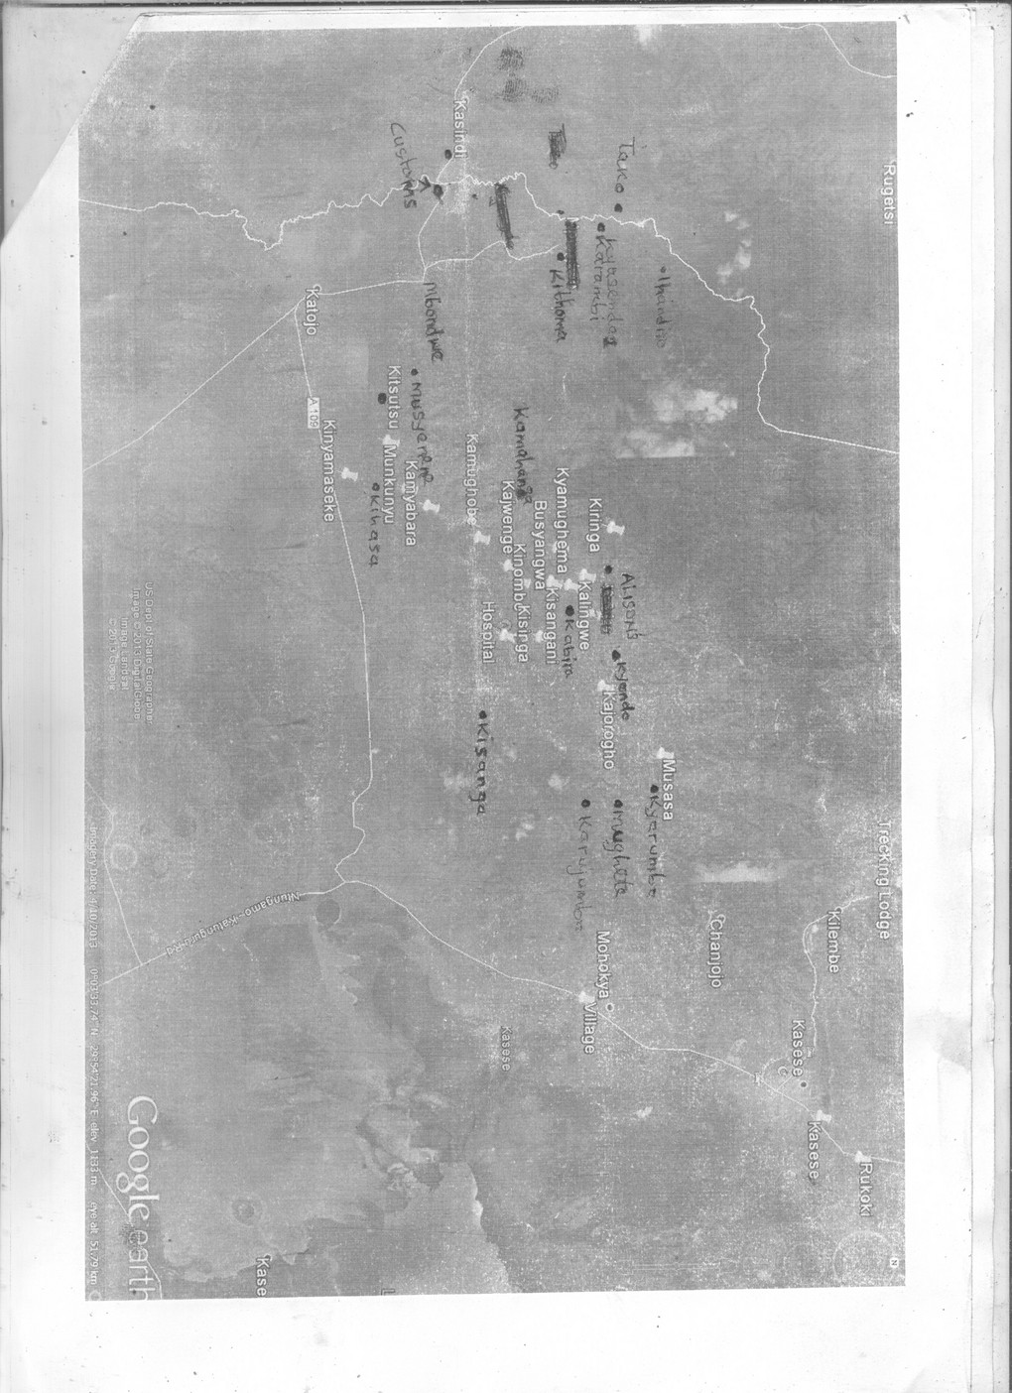

UP DATES ON PROJECT
During July 2013 visit up to date
MADE SAND FILTERS

ZONE | NO MADE | TYPE OF ZONE
Kihasa | 25 | Old
Kanyampara | 14 | Old
Musasa | 16 | New
Kitsutsu | 6 | New
Kyaminyawandi | 8 | New
Kyasenda | 50 | New
Thako | 10 | New
Kawando | 30 | Old
Kinyamseke | 11 | Old
 | 170

- Out of the total above have been commissioned and installed next communication is spread sheet and photos plus samples of flow rates.
95 sand filters are under curing process whose total amount required is 3,800, 000/= in regards to our usual working frame work of one pot 40,000 ug shillings

Your response sparks off the implementation of the proposed project activities elaborated above. Sorry for this long communication but its inevitable

Yours;
Sincerely,
Central executive committee
Compiled by
Jethro and Gedion

.

